Project Description

Introduction

At University Malaysia Pahang Al-Sultan Abdullah (UMPSA), students often face difficulty in accessing structured, high-quality learning materials outside regular class hours. Most online learning content depends entirely on individual lecturers’ efforts–some may upload videos or notes on external platforms like YouTube, while many others do not. As a result, students who wish to revise lessons, explore new topics, or learn additional skills beyond their coursework have limited options. The lack of a centralized e-learning platform within the university limits opportunities for self-paced learning, knowledge retention, and continuous academic development. This also affects the quality of the learning experience, as materials are scattered, unorganized, and inconsistent across courses and lecturers.

Problem

At Universiti Malaysia Pahang Al-Sultan Abdullah (UMPSA), many students struggle to access well-organized and reliable learning materials outside of their regular classes. Most resources are shared through various platforms, such as Google Drive, YouTube, or personal lecturer pages, which makes it difficult for students to keep track of what they need. Because everything is scattered, students often waste time searching for notes or lecture videos instead of focusing on learning. Without a single, centralized system, studying becomes less convenient and harder to manage, especially for those who prefer to revise or learn at their own pace. Another issue is the inconsistency in how lecturers share materials. Some lecturers upload complete sets of notes and video lectures, while others only share minimal content or none. This unevenness means that some students have access to plenty of resources, while others are left behind. It creates an imbalance in learning opportunities, affecting how well students can prepare for exams or explore new topics independently.
Lastly, learning outside the classroom often feels one-sided and less engaging. Since there is no proper e-learning platform, students have fewer chances to take part in interactive learning activities such as quizzes, discussions, or self-assessments. Lecturers also find it hard to monitor students’ progress or give timely feedback. As a result, many students lose motivation, and their learning experience becomes less effective.

Propose Project

In recent years, online education has transformed how students access knowledge and develop new skills. Global e-learning platforms such as Coursera, Udemy, and edX have set a new standard for flexible, self-paced learning. However, most universities, including Universiti Malaysia Pahang Al-Sultan Abdullah (UMPSA). Still lack an internal system that offers similar functionality tailored to their students’ needs. Currently, UMPSA students depend heavily on traditional classroom teaching or informal resources shared through messaging apps and scattered links. While this may work for routine coursework, it limits students who wish to study independently, revise lessons, or learn additional subjects beyond their syllabus. This lack of a centralized, high-quality online learning environment inspired the development of Ez2Learn.
Ez2Learn is designed as a comprehensive yet simplified online learning platform that combines the essential features of global learning systems with the specific requirements of UMPSA students and lecturers. It focuses on quality, accessibility, and ease of use, ensuring that learning can happen anytime, anywhere.
Main features of Ez2Learn:
a. User Management System
- Three types of users: Admin, Lecturer, and Student.
- Secure registration and login for all users.
- Admins manage roles, content approvals, and account maintenance.

b. Course Management
- Lecturers can create, edit, and manage courses.
- Each course can include video lectures, reading materials, and quizzes.
- Students can browse available courses and enrol with one click.
c. Video lecture library
- High-quality instructional videos uploaded by lecturers.
- Students can stream or re-watch content at their own pace.
- Video playback history and progress tracking ensure continuity.
d. Interactive Quizzes and Assessments
- Each course includes auto-graded quizzes to test understanding.
- Students receive instant feedback and can review incorrect answers.
e. Certificate of Completion
- Upon completing all modules and quizzes, the system automatically generates a digital certificate.
- Certificates can be downloaded or shared on professional platforms such as LinkedIn.
f. Progress Tracking Dashboard
- Personalized dashboards for students showing completed courses, scores, and ongoing progress.
- Lecturers can monitor student performance and participation levels.
g. Quality and Usability Focus
- Emphasis on software quality assurance, ensuring that all components are reliable, user-friendly, and maintainable.
- Usability testing and continuous feedback will help refine the interface design, loading performance, and content delivery.

Module 3 - Manage Assignments & Assessments

The Manage Assignments & Assessments module goal is to help both lecturers and students handle course tasks easily and efficiently. It gives lecturers an easy way to develop and manage assignments or quizzes, while students can submit their work, check deadlines, and review their results in a single platform.
Create:
Lecturers can create new assignments or quizzes for their courses and add important details like the title, description, due date, and total score. They can also upload important materials such as instructions or test questions for tests or an assignment. When a lecturer creates a new task, it automatically appears in the student’s dashboard and makes it easy for students to know what needs to be done.
Read:
Students can view all their assignments, deadlines, and marks in an orderly list. Also, they can read the instructions on the platform or download the files. While instructors may see all the assignments they created, monitor student's work, and grade every assignment.
Update:
Lecturers may need to make changes after an assignment has been created. They can edit information like the due date, grades, and even upload new files. Students can also update their submission before the deadline if they want to upload a revised version. This ability to change ensures that there won't be any misunderstandings or technological issues when both sides manage their tasks.
Delete:
Lecturers can remove old or unnecessary assignments to keep their course page tidy. Administrators also have permission to remove any duplicate or invalid entries to maintain system quality. When something is deleted, the system ensures that related data, such as student submissions and so on, are properly handled or deleted to keep the platform clean and secure.

Quality planning for the project

Quality factor involvement, Subfactor for each module, Definition and Subfactor for module

The “Manage Assignments & Assessments” module is an important module of the Ez2Learn system. This module manages functions like student assignments, how teachers grade them, and the overall tracking of student performance. For the system to work efficiently, several key qualities must be considered to make sure it’s reliable, safe, and easy to keep updated.

- INTEGRITY
Involvement Level: VERY HIGH
Definition: Integrity ensures that data remains accurate and unmodified throughout its lifecycle unless changed by authorized users.
Involvement in the module: Only authorized individual users are allowed to make any change to student submissions, grades, assignment files, instructions, or due dates in module 3.
Sub-Factors of Integrity:
- Data Accuracy
- Assignment submissions and grades are stored exactly as entered.
- No incorrect values are stored or displayed.
- Data Consistency
- The same grade appears consistently across student and lecturer views.
- No mismatch between database records and UI output.

- CONFIDENTIALITY
Involvement Level: VERY HIGH
Definition: Confidentiality ensures that information is only accessible to authorized users and protected from unauthorized disclosure.
Involvement in the module: Confidentiality means keeping sensitive academic data safe from people who shouldn’t see it. Access should be restricted because student submissions and assignments may contain personal information. This information should only be read or modified by approved users, such as lecturers or students.
Sub-Factors of Confidentiality:
- Access Control
- Role-based access (RBAC) for students and lecturers.
- Unauthorized users cannot view or modify assignments, grades or any related information.
- Authentication
- Secure login validation before accessing the module.
- Prevents unauthorized entry.
- Data Privacy
- Students can only view their own submissions and grades.
- Prevents unauthorized entry.

- MODULARITY

Involvement Level: VERY HIGH
Definition: Modularity ensures that the module functions work as an independent component within the overall Ez2Learn system.
Involvement in the module: Modularity means dividing different modules into separate sections, like assignment creation, submission handling, grading, and others, so that changes in one part don’t affect the other modules or functions. This makes the system easier to maintain, reduces bugs, and allows updates to be made more easily in future versions.
Sub-Factors of Modularity:
- Low Coupling
- Minimal dependency on external modules.
- Clear API boundaries.
- High Cohesion
- All functions in the module relate only to assignments and assessments

Organize the Quality Team

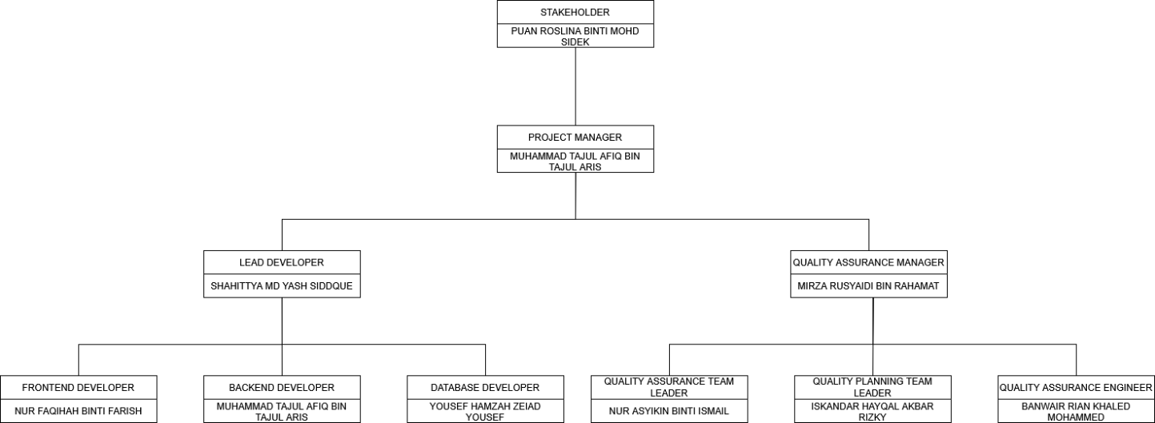

The Manage Assignments & Assessments module's Software Quality Assurance team works independently in the project structure to ensure that the project quality objective is unbiased and aligned with the project objective.
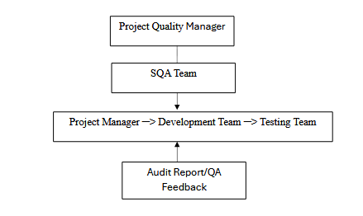
In this project,
- The SQA team is not involved in code development or implementation activities.
- The SQA Officer or assigned QA personnel who are not directly involved in developing the artefacts under review conduct all reviews, audits, and quality checks.
- The Project Supervisor and Project Quality Manager received audit results and quality reports for review and improvement measures.
At the top of the structure, Puan Roslina binti Mohd Sidek serves as the Stakeholder, providing overall supervision, direction, and approval for the project outcomes. Reporting directly to her is Muhammad Tajul Afiq bin Tajul Aris, the Project Manager, who oversees all development and QA activities, coordinates team communication, and ensures that the project meets its quality and timeline objectives. The Development Team, led by Shahittya Md Yash Siddque as the Lead Developer, handles system implementation and technical tasks. Supporting roles include Nur Faqihah Binti Farish as Frontend Developer, Muhammad Tajul Afiq bin Tajul Aris as Backend Developer, and Yousef Hamzah Zeiad Yousef as Database Developer. Together, they ensure the module is functional, secure, and efficient. The Quality Assurance Team, led by Mirza Rusyaidi Bin Rahamat as the QA Manager, ensures that all deliverables meet IEEE 730 and ISO/IEC 25010 standards.
Supporting roles include Nur Asyikin Binti Ismail as QA Team Leader, Iskandar Hayqal Akbar Rizky as Quality Planning Team Leader, and Banwair Rian Khaled Mohammed as QA Engineer. This team independently verifies and validates the system to maintain high-quality performance and security.

Measurement Metrics

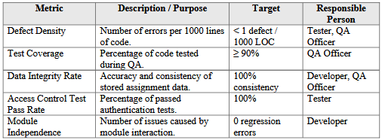

Planning

